Blackhawk Systems Ltd

GPS FlightMaster v7.6
TABLE OF CONTENTS
Introduction 3
Contacting the developer 3
Acknowledgements 3
Important Information 5
Conventions Used In This Manual 5
Disclaimer 5
InstalLATION 6
Pre-Requisites 6
Install Procedure 6
Installing Jeppesen NavData™ Databases 7
First Tasks After Installation 8
Bluetooth GPS Receivers 8
KEY Concepts 9
Controls 9
Display Pages 9
Command Popup 10
Input Dialogs 10
LEssons 12
Before You Begin 12
input methods 12
Lesson 1 – Creating a Flight Plan 13
Lesson 2 – Loading and Reviewing Plans 16
Lesson 3 – Simulating a Flight 18
Lesson 4 – Configuring the Four Maps 21
Lesson 5 – Scrolling Around the Map 22
Lesson 6 – Alternate Flight Plans 23
Preferences 26
More Preferences 26
GPS Page 28
Altitude correction 28
Simulation Mode 29
Flight Plan Databases 30
Introduction 30
Flight Selector 30
Saving a Flight plan 30
Standby/Alternate plans 31
CoPilot 31
Map Page 32
The Four maps 32
Map Configuration 32
PLAN rEVIEW mode 34
Selecting Items on the Map 35
Scrolling the Map 35
HSI Page 36
Bearing To/From 36
Turn rate indicator 36
VSI 36
GSI 36
DOP 36
Time Display 37
Horizontal Situation Indicator (HSI) 37
Attitude approximator 37
Safe Practice with the AA 38
FLAGS & Warning Messages 39
Flight Plan Page 40
Search Page 41
Searching for a waypoint 41
Timers Page 42
Overview 42
Naming the timers 42
Setting the timer 42
Waypoint Information 43
Omni Bearing Selector 44
Flight Monitoring 45
Introduction 45
Turn Anticipation 45
Roll Rate Indicator 45
Obstacle Warnings 46
Track log 46
Voice Alerts 46
System Messages 47
Vertical Navigation 48
Introduction 48
Setting up a VNAV profile 48
Approaching VNAV profile 49
Flying the VNAV profile 49
Ending the VNAV event 49
Database Management 51
Appendix A – databases 53
General 53
Airspace 53
Appendix B – CoPilot Waypoint Notes 55
Type field 55
Runway Information 56
Airfield Frequencies 56
Navigation Aid Frequencies 56
ILS Information 56
Hard Surfaces 56
Appendix C - Checklist 58
Aircraft Installation 59
Appendix D – Device-Specific Information 60
Garmin iQue 60
Palm Treo 60
Palm T3 60

Introduction
GPS FlightMaster is a software system for your PalmOS PDA that turns it into a powerful yet easy to use navigation system.
Kev says:
“Hello! I’m the lead developer of FlightMaster. Look for my tips throughout this manual.”
It is important that you read this manual in order to get the best out of your purchase.

Contacting the developer
FlightMaster has been extensively tested, however in the unlikely event that you discover a bug please report it via the website (http://www.flight-master.com) and it will be fixed as quickly as possible.
Feedback on FlightMaster’s current features, or possible new features you’d like to see included in a future release, is always welcome. All emails are usually answered promptly and personally. Check the website at http://www.flight-master.com for the latest announcements.

Acknowledgements
Thanks to Laurie Davis for his kind assistance in helping to integrate with CoPilot, and to Paul Tomblin for running the waypoint generator at Navaid.com. . Thanks also to all those who have purchased and supported FlightMaster - your support is appreciated!
And special thanks to Marcelle!

Part I Getting Started

Important Information

Conventions Used In This Manual

Tap the on-screen button, menu item or screen position indicated.
Key concept, or important information.
Flight Refers to an on-screen button.
Up Refers to a key on the PDA.

Disclaimer
Use GPS FlightMaster at your own risk. You are solely responsible for any loss or damage arising from your use of FlightMaster, howsoever caused. FlightMaster is only to be used as a backup to primary navigation methods.
WARNING: THE TERRAIN FEATURE AND DATABASE IS PROVIDED FOR PURPOSES OF AWARENESS NOT AVOIDANCE. YOU MUST NOT USE FLIGHTMASTER AS THE SOLE AUTHORITY FOR TERRAIN CLEARANCE. ALWAYS CONSULT YOUR MAP.
FLIGHTMASTER DOES NOT PROVIDE TERRAIN WARNINGS

InstalLATION

Pre-Requisites
You will require:
- A PalmOS 5.0 or later PDA with ARM-based processor. This includes: Palm TX, Palm Tungsten T3, Palm E2, Palm Treo 680 and the Garmin iQue 3600.
- 5-10MB of free space (internal to the PDA, depending on database sizes)
- SD Card with 100MB free (for terrain and obstacle databases)
- Compatible GPS receiver (*)
- Basic knowledge of using a PalmOS PDA, concepts such as the Application launcher, running applications, and opening the menus (consult the manual that came with your PDA).
- Basic knowledge of the HotSync™ process for installing software (consult the manual that came with your PDA)
(*) FlightMaster operates together with a GPS receiver that outputs NMEA messages via serial (RS-232), USB or Bluetooth. Please verify that your receiver works with FlightMaster before purchasing, by downloading and installing the trial version of the software.

Install Procedure
- Download the MS-Windows based installer from:
http://www.flight-master.com/download.html.
- Run the installer, and then select your PalmOS username from the drop down box:
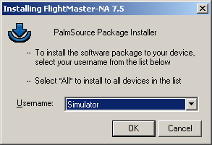
- Insert an SD card (with at least 100MB of free space) into your PDA..
- Start the HotSync™ process.

Installing Jeppesen NavData™ Databases
If you have purchased FlightMaster with an up-to-date Jeppesen NavData™ database then you will receive an email with a link to your NavData™ download.
- Download the NavData™ ZIP file to your PC by using the link in the email you received.
- Double click on the ZIP file to open it and see the two database files:
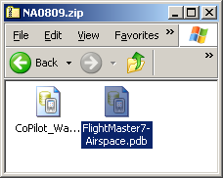
- Double click on each file in turn to queue the files for installation. Your installer window will look like this:
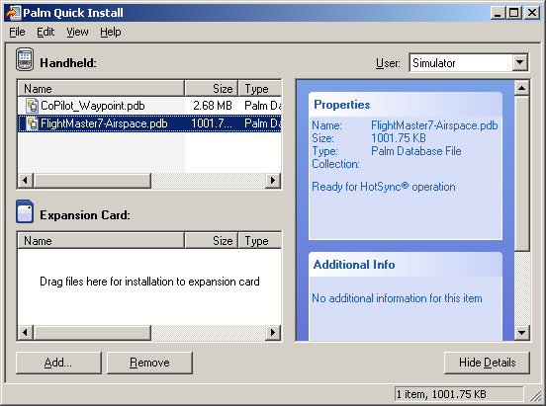
- Start the HotSync™ process.

First Tasks After Installation

Indexing
FlightMaster needs to build an index of the waypoint database the first time it runs, and any time after the database is modified. This process will normally take a few minutes.

Entering Your Registration Code & Setting up Your GPS
You must enter your registration code to fully activate the software. You also need to select your GPS type. Both tasks can be done on the Preferences dialog, which is accessed by opening the menu and selecting “Preferences”:
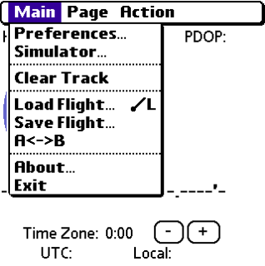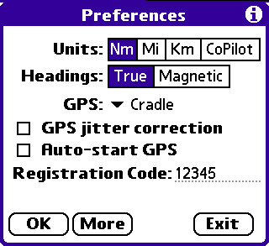
The other options in the Preferences dialog, including the “More” button, are discussed in the Preferences section later in the manual.

Before you fly…
FlightMaster has a basic simulation mode that allows you to experiment with its features from the safety of your armchair. It is strongly recommended that you become familiar with FlightMaster in simulated flight before trying to use it in the air.

Bluetooth GPS Receivers
If you have a Bluetooth GPS receiver then you need to ensure that you can connect it to your PDA. Consult the documentation that came with your PDA and/or your GPS receiver for further information.

KEY Concepts

Controls
FlightMaster has been designed to be very easy to use while in flight, by re-assigning the PDA’s keys to other functions - you will need to become familiar with these assignments.
The diagram below shows the layout of a Palm TX, but other PDAs will be very similar - please see the appendices for device-specific differences.
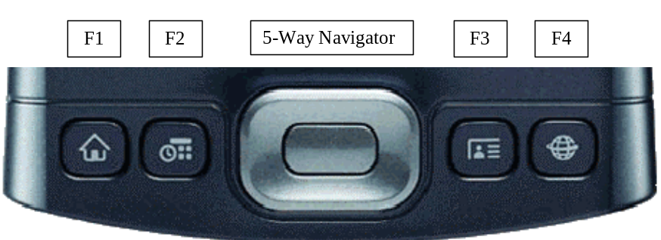
This document will refer to the keys shown above as F1 to F4. The 5-way navigator comprises Up, Down, Left, Right and Select i.e. the middle button. These buttons are your primary means of controlling FlightMaster.

Display Pages
FlightMaster gives you access to six separate pages of information. The first way to select which display page to view is by using the F3 or F4 keys:
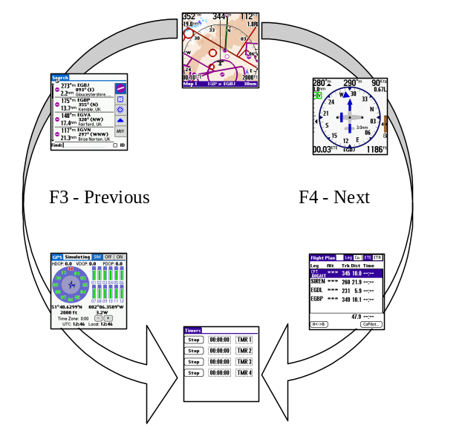

You may also use the Page menu to jump directly to another page (though this is not recommended during flight as it’s not as easy to do):
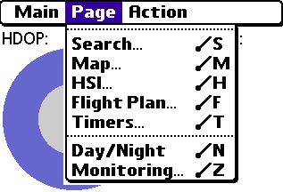

Command Popup
You may go directly from one display page to another by using the Command Popup. Press F1 when viewing any of the six display pages to display the Command Popup. Tapping on one of the buttons in the top line of the popup will take you directly to that display page.
The Command Popup is also the central point from which you access most of FlightMaster’s other features. There will be more information about these features later in the manual.
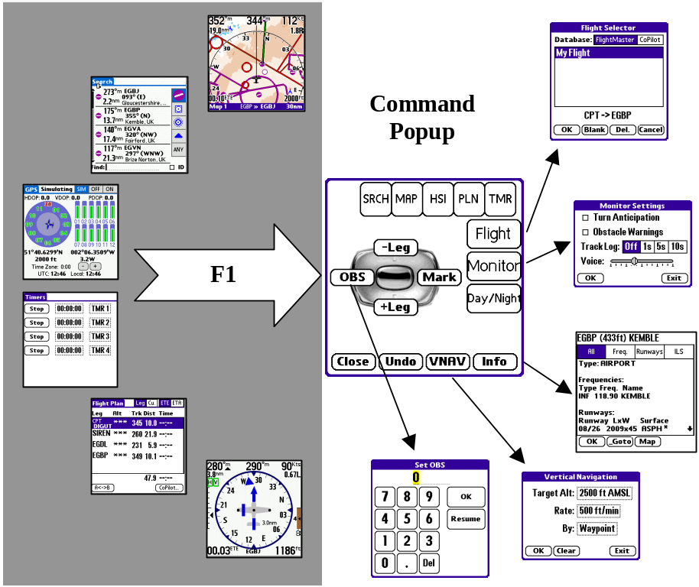

Input Dialogs
When an input dialog is open, you may use function keys F1 to F4 as shortcut keys for the buttons on the bottom row of the dialog, rather than tapping on the screen. In the example below, F1=OK, F2=New, F3=Del. and F4=Cancel.
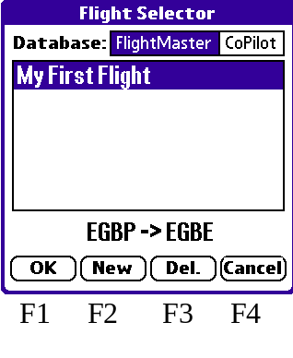
You will sometimes see dialogs with buttons that are missing. In the example below the F1, F2 and F4 keys are equivalent to OK, Clear and Exit respectively:
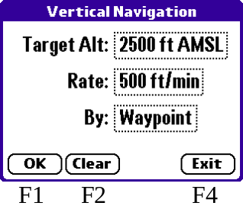
You will sometimes be asked to input a numeric value, using an on-screen keypad dialog. In this case the F1 to F4 keys can be used as shown below:
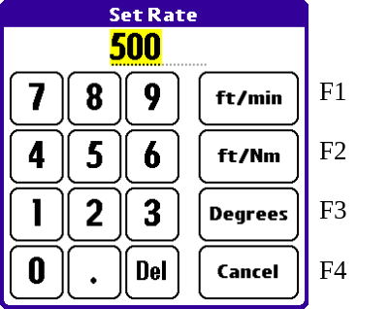

LEssons
These lessons are designed to teach you how to get started with FlightMaster. You will learn about how to create and manage flight plans, how to modify flight plans in flight, and FlightMaster’s simulation mode.
The lessons take less than 40 minutes to complete, and it is well worth investing this time – it will give you valuable experience in using FlightMaster. You are advised to follow the lessons in order as each builds on the knowledge gained in the previous one.
If you’re the sort who likes to take off and go at their own pace, you can skim-read the lessons, paying particular attention to the “key concept” icons (as pictured left) to extract the most important information you need.

Before You Begin
You should review the previous section (Key Concepts) and ensure that you are familiar with the basic operation of your PDA’s controls.

input methods
Your PDA will have various methods to allow you to input letters & numbers, for instance a Graffiti-2 input area, an on-screen keyboard or a physical keyboard. You should be familiar with at least one of the methods, as you will need to be able to enter waypoint identifiers to select airports and navigation aids.
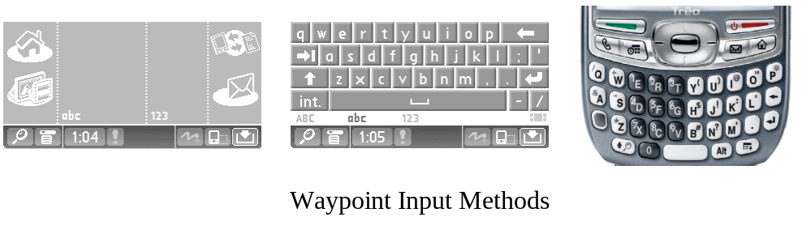

Lesson 1 – Creating a Flight Plan
This lesson will take approximately 10 minutes. You will learn how to:
- Create a new flight plan  - Locate waypoints on the map  - Add waypoints to a plan | - View the map in Scroll* mode  - Zoom In & Out of the map  - Save a Flight Plan
You need to have in mind a route that you may already be familiar with. This tutorial will use a plan from EGBP -> DTY -> EGBE, all of which are based in the UK, however any route in your area, and with 3 or 4 waypoints, will suffice.

Press F1, then hit Map to go to the Map page.  Notice that you are in Map mode, indicated by “Map 1” in the bottom left of the map screen.  NB The map may be blank if this is the first time you’ve used FlightMaster. | 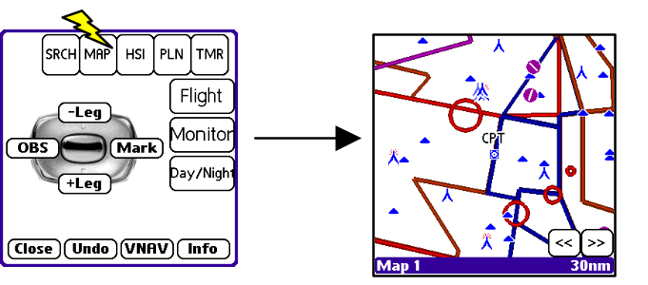
Press F1, hit “Flight”, then “New”. | 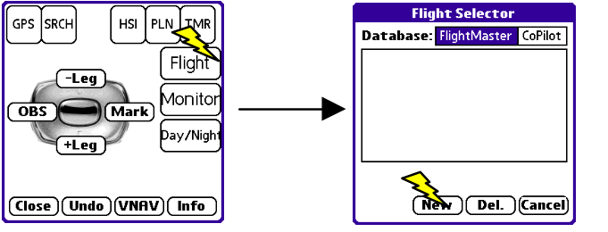
Using your PDA’s input method, type EGBP (or the identifier of your chosen starting waypoint) and press ENTER | 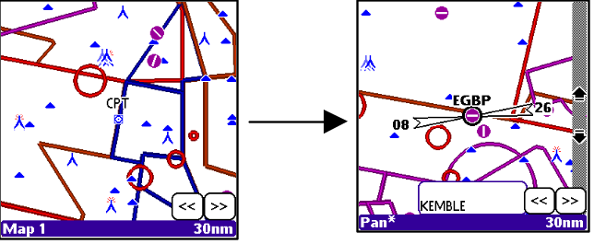
Typing a waypoint identifier and pressing ENTER selects the waypoint and scrolls the map to the waypoint. To deselect the waypoint, tap anywhere in the waypoint information box at the bottom of the screen.
Notice the gray bars at the right of the screen – these allow you to zoom in and out of the map while it is in Scroll* mode (more on Scroll* mode in a little bit). In Map mode, you use the Up & Down keys of the 5-way navigator to zoom in and out.
You are now ready to add the waypoint to your plan.
Press F2 to add the selected waypoint as the first waypoint in the plan.  Type EGBE (or the identifier of your chosen end waypoint) and press ENTER.  Press F2 to add the waypoint to the plan. | 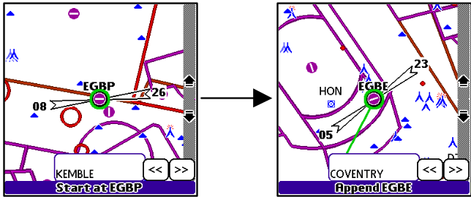
We’ve got a basic flight plan between two waypoints, and now we want to add our intermediate waypoint, DTY. Rather than type its identifier, we’ll scroll the map to it.
You’ll notice that the map says “Scroll*” in the bottom left corner. This indicates you are in a free-scrolling mode, so you can use the 5-way navigator to Scroll the map around. Have a play with this feature now.
To return to Map mode, press the Select button. Press Select again 3 times to re-enter Scroll* mode. The other scroll modes are discussed later.
Now we’re going to add our next waypoint. Find DTY (or your own waypoint) by scrolling the map, and then tap on the waypoint to select it. Sometimes there is more than one waypoint or airspace near the tap-point, so just tap again until the correct waypoint is highlighted. If you’re lost and can’t find the waypoint, don’t worry – simply type its identifier and press ENTER.
Press F2 – FlightMaster will append the waypoint, which is not what we want, so press F2 again and again until the plan is correct (see the sequence below).
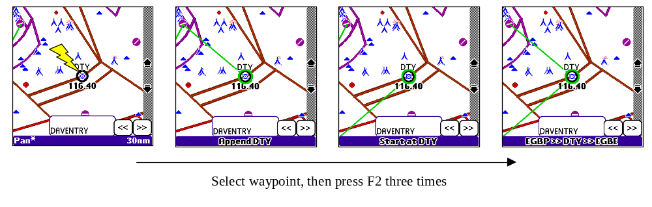
Whenever you want to make changes to your flight plan, select the waypoint you want to add or delete, then just press F2 again and again until the plan looks correct. Each press of F2 moves the selected waypoint along in the existing plan.
Approximately 5 seconds after you press F2 , or when you select a new waypoint, the edit will be fixed into your flight plan.
If you ever want to use a point that isn’t in the waypoint database (e.g. the edge of some airspace, or another arbitrary point), simply tap the map where you want to put the point. FlightMaster marks the point with a Cursor. Just press F2 to add the point as normal.
Now we’re going to save our flight plan, so we can use it in the next lesson.
Open the menu and select “Save Flight…”  Enter a name for the flight  Hit OK | 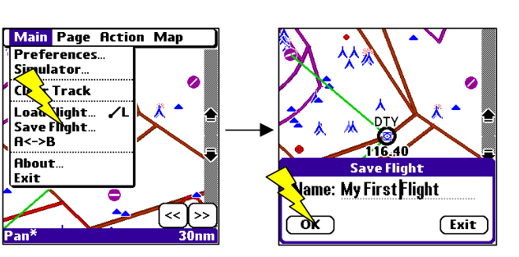

Lesson Review
You’ve learned a lot of important concepts already. Hopefully, you can see how easy it is to create flight plans within FlightMaster. The good news is that the same concepts apply when you’re in flight too, so changing your flight plan while enroute is just as easy (more on this later).
Here are some further exercises for you to try:
- Add another waypoint or two after DTY and notice the behaviour of the F2 button as you are building waypoints into your flight plan.
- Use the Cursor feature to add an arbitrary point to your plan.
- Select a waypoint that is already in your plan, and press F2 to see what happens.

Lesson 2 – Loading and Reviewing Plans
This lesson will take approximately 5 minutes. You will learn about:
- Loading a flight plan  - The Plan Review controls | - Deleting waypoints from your plan  - The Undo feature

Go to the map page, then select “Flight” from the Command Popup.  Highlight your previously saved flight from Lesson 1 and select OK.  You’ll be asked about Loading an Alternate Flight Plan – just say Yes for now (more on this feature later). | 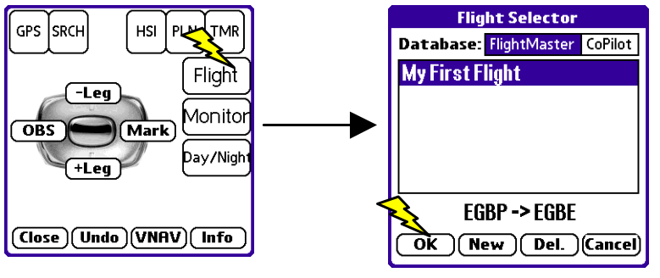
There are two plan review buttons at the bottom right of the map page, which allow you to move the map back and forwards along the waypoints in your flight plan. | 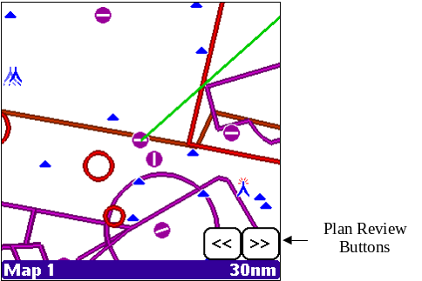
Now we’re going to look at the Delete and Undo features.
Use the review controls to move to the second waypoint in your plan, and then tap on the waypoint to select it.  Press F2 to delete the waypoint. | 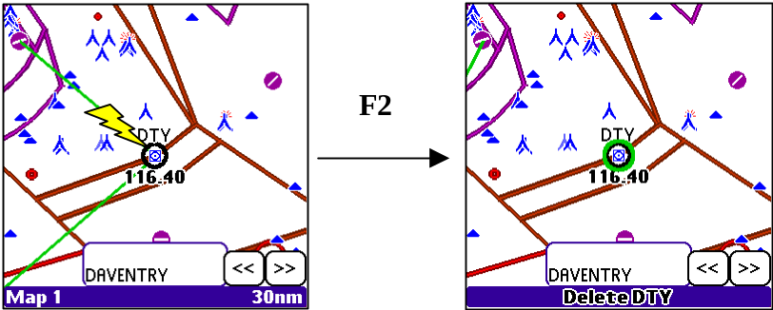
Now let’s undo that change: press F1, then F2 to Undo the last edit you made.  FlightMaster has restored your flight plan. | 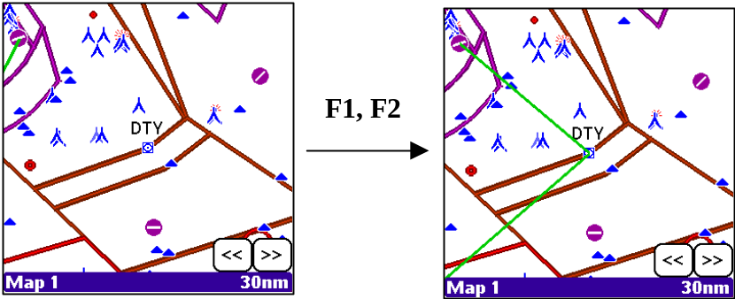
FlightMaster creates a copy of the flight plan each time you modify it. The Undo feature allows you to step backwards one modification at a time. This history of your editing is saved even when you leave FlightMaster.
The history is erased whenever you create a new flight plan or load an existing flight plan.

Lesson Review
You’ve learned how to load a flight plan, and how to delete waypoints. You’ve also discovered that FlightMaster has a powerful editing history feature, and how to access that via the Undo function on the command popup.

Lesson 3 – Simulating a Flight
This lesson will take about 10 minutes. It will teach you how to operate FlightMaster during simulated flight conditions. The behaviour of FlightMaster during simulation is identical to how it behaves when connected to a real GPS, so this is an important lesson.
In this lesson you will learn about:
- Controlling the simulator  - Manual leg sequencing | - Diverting from your original plan  - The Flight Plan page

Load the flight plan you created in Lesson 1, then goto the map page.  Open the menu and select ‘Simulator…’, then enter sensible values for heading, altitude and speed for your first leg. | 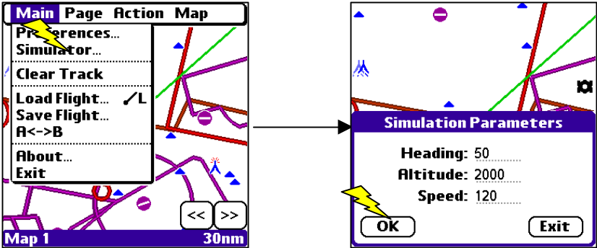
Go to the GPS page, then select the ‘SIM’ button and return to the Map page by pressing F4 twice.  Your simulated aircraft is in flight! The map has data readouts around the edges to assist your situational awareness. | 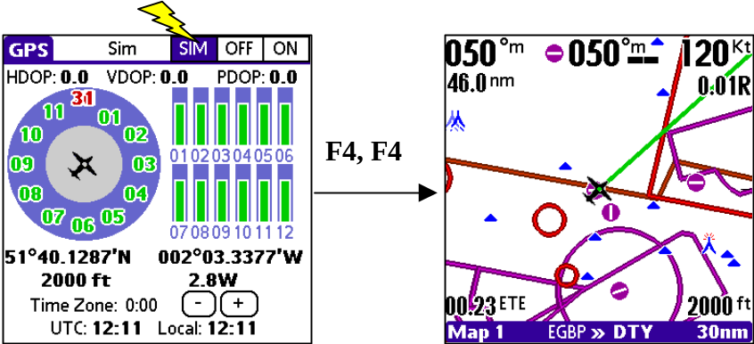
Use the ‘Simulator…’ menu options anytime you want to change your airspeed, heading or altitude.
Zoom in and out of the map using the Up & Down keys.
Now you’re going to learn about managing diversions while in flight. It’s fairly common to have to change your flight plan while airborne, and FlightMaster lets you do this easily.
It should come as no surprise that everything is done using the F2 key!
Make sure nothing is selected on the map, then press F2.  This creates a direct line from your present position to your next waypoint.  Press F1, F2 (Undo) to undo the change. | 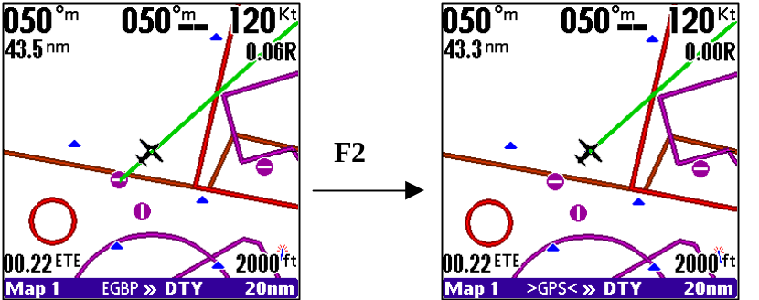
Select a waypoint (by tapping on the map) that is not an airfield and press F2.  FlightMaster creates a diversion from your present position to the waypoint, and then on towards your original waypoint.  Press F1, F2 (Undo) to undo the change. | 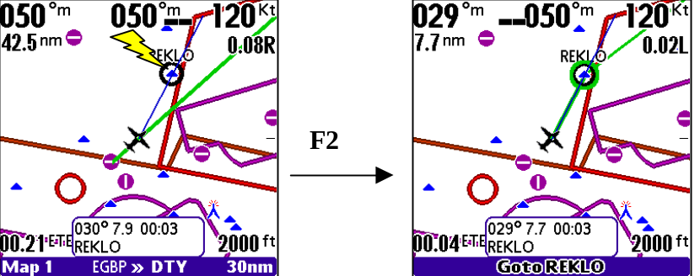
With the waypoint still selected, press F2 twice within 8 seconds - FlightMaster edits the waypoint into your original plan. From then on, pressing F2 gives the same behaviour as when you were planning your flight.  Press F1, F2 (Undo) to undo the change. | 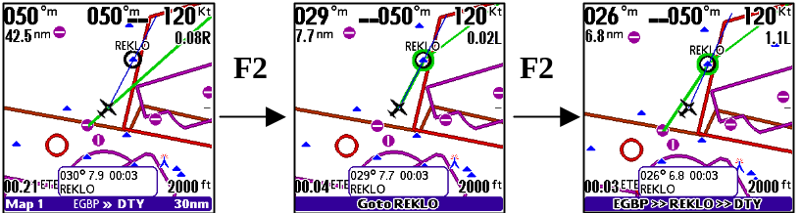
Now select a nearby airfield and press F2. Notice the slightly different behaviour? FlightMaster assumes you want to go to the airfield and land there. | 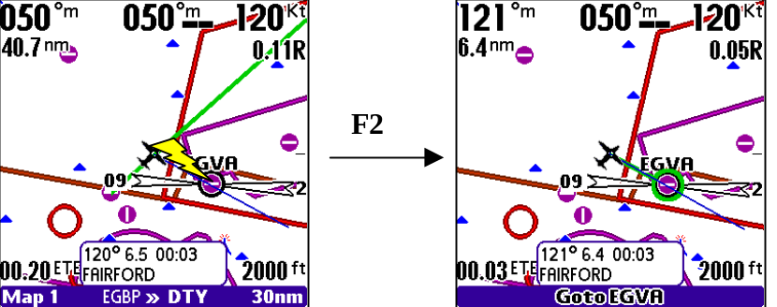
If you want to over-fly the airfield, just press F2 again within 8 seconds of the first press.
This is a really good time to experiment with the F2 key, to get a good feel for how it works. When you’re finished experimenting just Undo all your changes, or simply re-load your original flight plan.
Now you’re going to learn about the Flight Plan page, to get more detailed distance and timing information about your entire flight.
Go to the Flight Plan page (F1, then hit PLN).  The Flight Plan page gives you time and distance information for all the legs in your flight plan. | 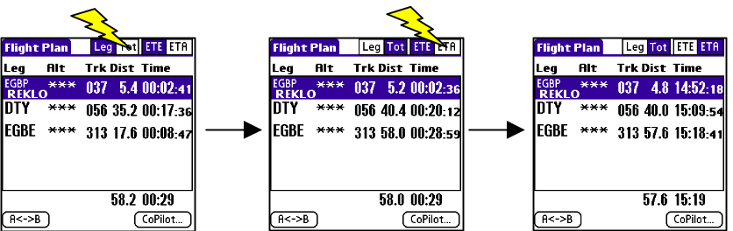
The buttons at the top control the data in the distance and time columns. ETE/ETA is self-explanatory. Select “Leg” if you want to see the distance/time for each individual leg, or select “Tot” to see the total distance/time from your current position to the end of the leg.
Tap on the row for a leg to change the current leg.
You can also sequence one leg forwards or backwards using the “+Leg” or “-Leg” buttons on the command popup – this is available from any of the six main pages.

Lesson Review
This was a very important lesson, in which you learnt how to manage your flight plan whilst in flight.
By now you should be confident in making changes to your plans with the F2 key, both in planning (GPS off) and flight (GPS on) modes. You should also know how to manually sequence your flight plans and how to use the Flight Plan page to track your time & distance remaining.

Lesson 4 – Configuring the Four Maps
This lesson will take about 5 minutes. In this lesson you will learn about the options available to customise each of FlightMaster’s four independently configurable maps.
Load the flight plan you created in Lesson 1, then goto the map page.  Press F1 twice to open the map configuration dialog.  Tap on the settings boxes to change them. Refer to “Map Configuration” on page 41 for further details. | 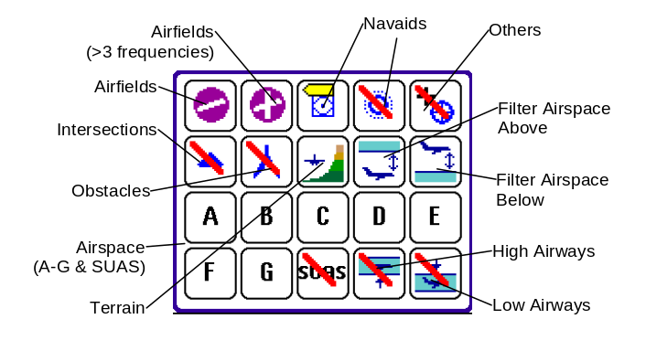   Hide these items  Label these items
Press F1 again to proceed to the next page of configuration options.  Refer to “Map Configuration” on page 41 for further details. | 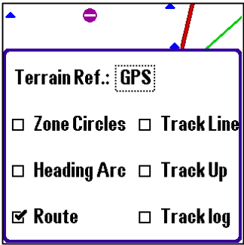
Press F1 to return to the Map page. Notice that FlightMaster shows “Map 1” in the bottom left. You use Left and Right when in Map mode to change between the four maps.
Press Right to change to Map 2, and then press F1 twice to open the configuration dialog. You are now able to configure a different set of map display options, specific to Map 2.
Change some of the settings, then press F1 twice to return to Map 2.
Press Left to go to Map 1 –FlightMaster recalls your Map 1 settings and re-applies them to the display.

Lesson Review
You have seen that FlightMaster has four separately configurable map displays, and how easy it is to move among them and change their configurations.
You should now have an idea in your mind about how best to set up the maps for your own preferences, to better assist you during planning and flying.

Lesson 5 – Scrolling Around the Map
This lesson will take about 5 minutes. You will learn about the remaining options for moving around the map to display different areas that are related to your flight plan or otherwise.
Load your flight plan from Lesson 1 and then go to the map page.
Set up Map 1 so that it is in Track Up mode.
Go to the GPS page and start the simulator, then return to the map page.
Press Select to enter Scroll mode.  The map is centred on your aircraft. Use the Left, Right, Up or Down button to enter Scroll* mode, and scroll away from your aircraft. | 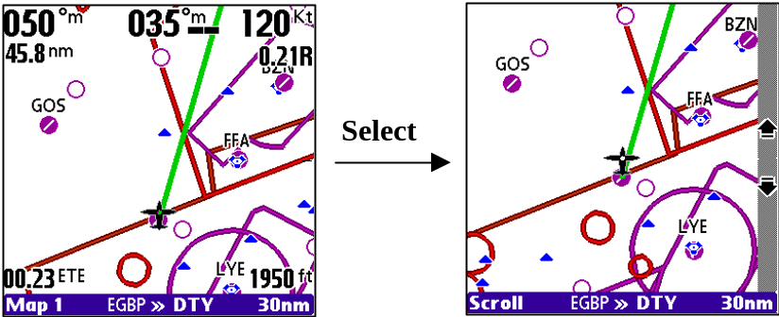
Notice that all scrolling movement is relative to your aircraft’s current track when the map is in Track-Up mode. This may prove confusing if you Scroll too far away from your aircraft.
Press Select again to return to Map mode, then press Select twice to enter Scroll/FP mode.
In Scroll/FP mode, you use Left and Right to move forwards and backwards along your flight plan. You can also zoom in and out using Up and Down.  Press Select again to enter Scroll* mode. | 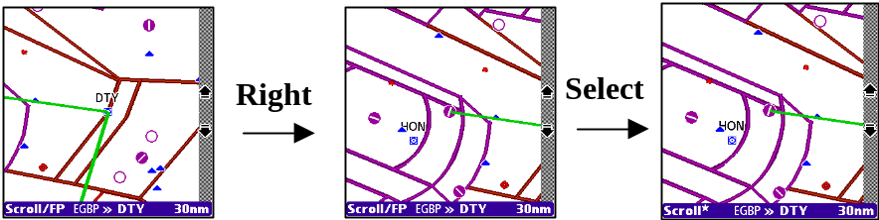
You can Scroll around the area before pressing Select again to return to Map mode.
From Map mode, press Select three times to jump back to the last map position you were viewing, and enter Scroll* mode

Lesson Review
You should now know how to quickly move the map to another location away from your aircraft, either by using Scroll/FP or Scroll* mode.

Lesson 6 – Alternate Flight Plans
This lesson will take about 10 minutes. You will learn the important concepts of how FlightMaster lets you manage alternate flight plans, by using its standby plan feature and the flip-flop switch (also known as A<->B).
Goto the map page, load your flight plan from lesson 1.  Now go to the Flight Plan page, and hit the A<->B button. Your flight plan should change – it will probably be blank. | 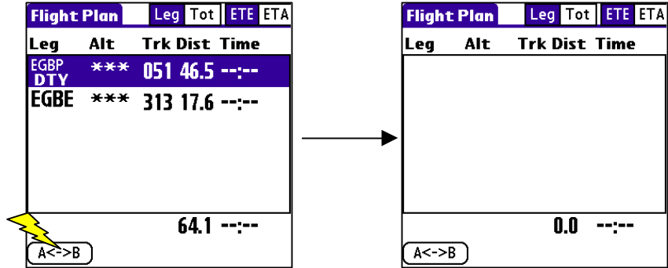
The A<->B button toggles between your active and standby (alternate) flight plans. Even more than that, the editing history of both your active and standby plans is retained, so you can edit your primary plan, flip to your standby, flip back to your primary and undo the changes.
Your standby flight plan is also saved when you save your primary flight plan. Whenever you load a flight plan, FlightMaster asks if you want to load the standby plan over your existing standby plan.
Now we’re going to enter an alternate plan from EGBE (our original destination) to EGBB (our alternate).
Create a new flight – F1, Flight, F2.Then go to the map page and create a plan for a route from EGBE to EGBB.
Go to the Flight Plan page.  Hit the A<->B button to restore your original plan. | 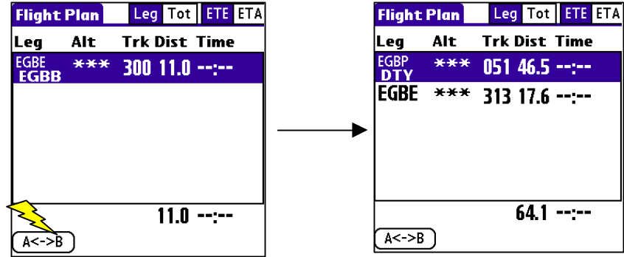
Save your flight. This saves your primary and standby plan together.
Whenever you load a flight, FlightMaster asks if it should load the alternate plan into the standby plan. If you select “No” then the standby plan is left alone, and only the primary flight plan is loaded. This feature can be used in many ways, for example to load a pre-programmed approach:
- Flip primary to standby (press A<->B)
- Load a pre-programmed approach plan and select “No” when asked to load the alternate
- Flip back to the primary plan

Lesson Review
You’ve learnt how to create and store an alternate flight plan, and how the alternate is stored along with your primary plan when you save a flight. You also know how to easily switch between the two plans, using the flip-flop button on the Flight Plan page. Finally, you know that you can choose to load the alternate plan or not whenever you load a new flight plan.

Part II Reference

Preferences
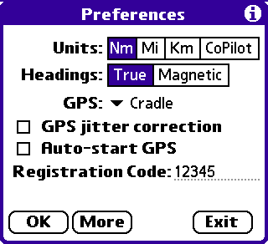
Select the “Preferences” option from the menu to open this dialog.

Units
FlightMaster can display data using Nautical (Nm), Statute (Mi) or Metric (Km) units, or the units you have selected in CoPilot.

Headings
FlightMaster can work with headings and bearings in degrees true or degrees magnetic. Note that textual bearings are always relative to true north – e.g. N (North) is 0º True

GPS Source
FlightMaster can accept NMEA input from the serial port (default), a slot-in GPS card, a Bluetooth GPS transmitter, or a Garmin iQue. It may also run in simulation mode (see Simulation, later). To change the input, select the desired source and then restart the GPS (see GPS Page).

GPS Jitter correction
This setting forces FlightMaster to assume that your GPS source is outputting data once per second and helps stabilise the Attitude Approximator. This is useful for interfacing to older GPS units that do not output the required timing information, or for Flight Simulator 2002/2004 in conjunction with GPSOut.

Auto-start GPS
If this option is selected, then the GPS is always started when FlightMaster launches. Your PDA consumes more power when the GPS has been started.

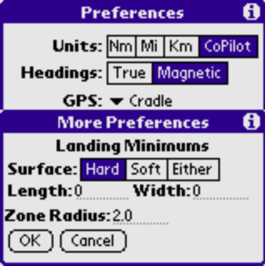Registration Code
You need to enter a valid registration code for the registered version of FlightMaster. Enter the code into this field and press “OK” to validate it.

More Preferences
Select the “More…” button on the Preferences Dialog to reveal further FlightMaster configuration options.

Landing Minimums
These settings allow FlightMaster to determine which airfields are suitable for landing using the particular aircraft that you are flying (take into account your own piloting skills - remember that the landing distance specified for an aircraft was probably derived by a very experienced test pilot). This information affects the airfields that you will see on the Search page, and is also used when you activate an emergency diversion. See Appendix A for a list of surfaces that are considered ‘hard’ – other runway surfaces are ‘soft’ by default.
The runway dimensions that you specify should be in the same units as those used in the CoPilot system database. If you change the units in the CoPilot database, you must change these values to match your new units.
Note that the runway lengths specified in the waypoint database are the entire runway, not the Landing Distance Available – they are likely to be different, but in an emergency you probably wouldn’t care!

Emergency Diversion
Press and hold F2 for more than one second. The nearest suitable airfield within 2000nm (based on the information in the landing minimums) becomes the diversion destination.
You are strongly advised to review the list of the nearest airfields on the Search page - there may be a more suitable airfield (perhaps allowing for wind, or time to turn onto a new course etc.).

Zone Radius
This setting controls the radius of the zone circles around airfields on the map pages.

GPS Page
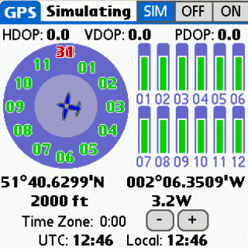The GPS page shows satellite signal strength, constellation information, GPS fix type, and precision data.
The On/Off buttons allow you to control whether or not FlightMaster listens to the messages from your GPS. Press SIM to put FlightMaster into simulation mode (see below).
Kev says:
“Don’t forget to select your GPS type in the Preferences dialog, otherwise you’ll have problems.”

Satellite constellation
FlightMaster depicts satellite coverage using a satellite constellation diagram. Satellite ID numbers appear inside the blue circles relative to your present location (North is up). The edge of the inner circle represents 45 degrees of elevation; the edge of the outer circle is the horizon.
Kev says:
“The satellite constellation isn’t just pretty – it’s useful too. One time I lost GPS signal and when I checked this display I found that most of the satellites were on the left side of my aircraft. Moving the receiver to the left regained GPS lock.”
Different colours show the relative signal strengths received from the satellites. Red means weak and that the satellite is not being tracked, amber means OK & tracking, and green is good. The signal strengths are also shown in bar-chart form to the right of the constellation.

Time Zone
Set your local time zone relative to UTC by using the ‘+’ and ‘-‘ buttons. The time zone setting allows 30 minute increments from –11:30 to +13:00. If you are flying East or West across time zones you can visit the GPS page to update the time zone periodically.

Altitude correction
GPS and barometric altitude rarely agree, and most pilots prefer (quite rightly) to rely on the barometric altimeter reading. If you are using the VNAV feature then you will most likely want to ensure that the barometric altitude and the FlightMaster-reported altitude are similar.
Kev says:
“There have been studies that show that GPS altitude is often a lot more accurate than barometric altitude. Nontheless, it is important you not rely on GPS alone for altitude. ”
The altitude correction feature allows you to do this. Press Up and Down to change the reported altitude and bring it into line with your altimeter. Warning – always ensure that the GPS altitude is set Above Mean Sea Level, and not relative to an airfield.

Simulation Mode
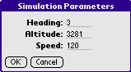
FlightMaster has a simulation mode that allows you to experiment with its functions without using a real GPS source. You are strongly encouraged to learn FlightMaster’s functions using this mode.
When you start the simulation, your aircraft is positioned at the centre of the map, where you last left the map page. Control the parameters of the simulation by calling up the Simulation Parameters dialog from the menu.
These are target values: when you change them, the simulated aircraft will smoothly turn, climb or accelerate as necessary to the new targets: climb/descend at 800 feet per minute, turn at 3 degrees per second and accelerate/decelerate at 5 kts per second.

Flight Plan Databases

Introduction
FlightMaster has a built in flight planner. Alternatively you may want to use the CoPilot program developed by Laurie Davis. In either case you can maintain a database of flight plans, and use the Flight Selector to load a flight plan into FlightMaster. You can mix and match which flight planner you use to suit your needs.

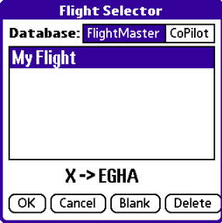Flight Selector
Press F1 + Flight to open the flight selector dialog

Loading a flight
Select which flight plan database to use by pressing FlightMaster or CoPilot. Then select the flight from the list box.
If your CoPilot flight has more than one segment, you can choose among them by pressing Seg> (which only appears when a CoPilot flight with more than one segment is selected).
Press OK to load the flight. If the CoPilot or FlightMaster flight plan has an alternate plan you are asked if this should be loaded into “Plan B” which is the standby plan (see below). Loading a flight will clear the editing history of the current plan and cannot be undone.

Deleting a Flight
Select the flight plan in the list then select Delete. You cannot delete a CoPilot flight from within FlightMaster.

erasing all waypoints
If you want to start planning a new flight, select Blank to erase all waypoints from the flight plan. This only affects the current plan, and does not alter any plans stored in the flight plan databases.

Saving a Flight plan
Select “Save Flight…” from the main menu to name and store a flight plan into the FlightMaster database. You cannot save a flight from FlightMaster into the CoPilot flight database.

Standby/Alternate plans
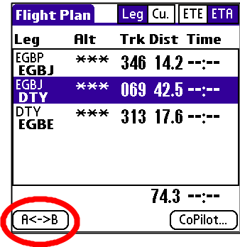FlightMaster supports alternate flight plans via the use of its unique Flip-Flop mechanism.
An alternate plan is held in standby as ‘Plan B’. A simple press of A<->B on the Flight Plan page toggles between the two.
There is also an A<->B menu option, and if you own a Treo650 or Treo680 you can use the Alt key on your PDA’s keyboard (to the right of the space bar).
All editing or modifying operations only affect the current flight plan, while the standby plan is held safely out of the way. More than that, the entire editing history of the standby plan is also maintained and recalled when the Flip-Flop is triggered.
Kev says:
“Flip-Flop is an extremely powerful feature. Being able to maintain two independent plans and their editing history is a unique ability.”

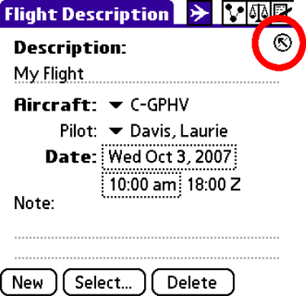CoPilot
You can launch FlightMaster from CoPilot to use the current CoPilot flight plan (use the FlightMaster button from within CoPilot – see right). See the CoPilot documentation for more information.

Map Page
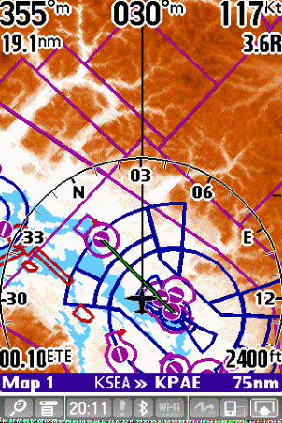FlightMaster’s moving map page shows you a birds-eye view of your present position and surroundings comprising airfields, navaids, intersections, obstacles, airspace and airways.

The Four maps
The map page shows one of four individually configurable map screens, numbered 1 to 4. Change between these map screens by using Left and Right .
Make your flight easier by setting up the map pages in advance of your flight. A suggested configuration is:
- Immediate vicinity. Airfields, Navaids, Obstacles, Airspace. Zoom to 30/40nm. Zoom in to 10/20nm during take off & approach.
- Overview. Large airfields, Navaids (label), airspace. Zoom to 50/75nm.
- IFR. Airways (lower and/or upper), Airspace, Intersections, Navaids (label). 50/75nm zoom.
- System Map. FlightMaster will sometimes override the settings on this map to show you warnings. Think of this map as a bit of scrap paper and use it for one-off views that you don’t intend to reuse.
The status bar at the bottom of the screen shows the map number, current leg information and map zoom setting. The zoom setting represents the width of the status bar. Zoom in by pressing the Down key, zoom out by pressing the Up key.
Kev says:
“Having four maps is very convenient – it means not compromising on what you need to display.”

Map Configuration
Open the Map Configuration Dialog by selecting F1 twice. This dialog controls what information is shown on the current map. Each of the 4 maps has its own copy of the settings in this dialog. The dialog is spread across two pages – press F1 again to access the second page.
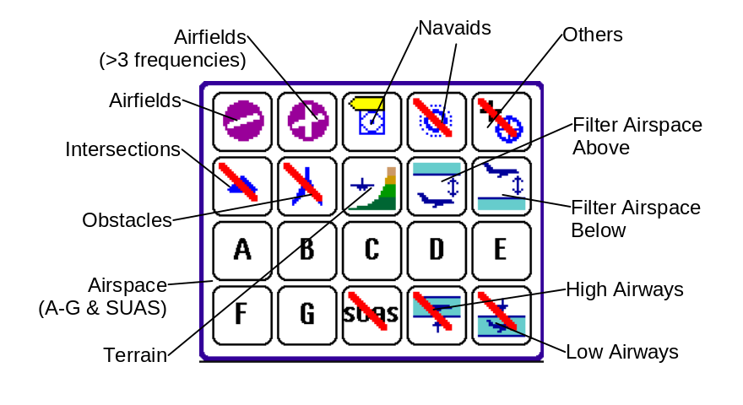
On the first page, there are buttons controlling icons and airspace (as shown in the diagram) and each of these may be set to hide, show, or show with labels.
On | Label | Off

The Filter Airspace above & below buttons allow you to hide airspace and airways that are more than 1,2 or 3 thousand feet above (or below) your present GPS altitude. When active, FlightMaster will also de-emphasise airspace more than 300ft away from you. As you climb or descend you will see airspace flashing if you are within 60 seconds of reaching its altitude.
FlightMaster will not hide or de-emphasise airspace whose lower or upper limit is specified as Above-Ground-Level (AGL).
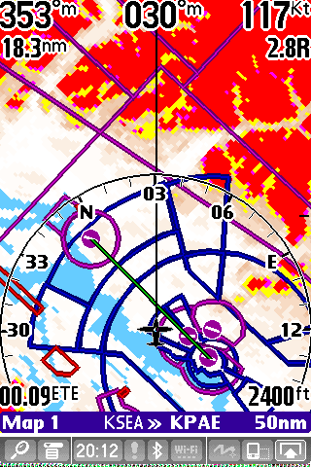
The terrain button controls the terrain display and has four possible states:
 Off – Terrain is not shown
Normal – terrain is shown with colour-coded height bands
Normal+Conflict – terrain is shown, and highlighted where it conflicts with your present GPS altitude (as shown in the diagram, right)
Conflict only – terrain is shown only where it conflicts with your present GPS altitude.
WARNING: THE TERRAIN FEATURE AND DATABASE IS PROVIDED FOR PURPOSES OF AWARENESS NOT AVOIDANCE. YOU MUST NOT USE FLIGHTMASTER AS THE SOLE AUTHORITY FOR TERRAIN CLEARANCE. ALWAYS CONSULT YOUR MAP.
FLIGHTMASTER DOES NOT PROVIDE TERRAIN WARNINGS
Terrain conflict is based on your present GPS altitude. There are three bands:
Yellow | 1000ft to 500ft below
Purple | 500ft to 250ft below
Red | 250ft below ft below to 0 feet, and above.

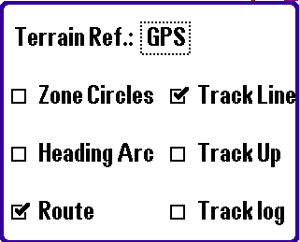
Press F1 to move to the second map configuration page.
The checkboxes on this page are:
- Track Line. Shows a line extending from the aircraft forwards along your present track, a line from your aircraft to the next waypoint, and a blue line pointing to the selected waypoint (if one is selected).
- Zone Circles. Draws zone circles around the airfields on the map (the radius of these circles is set in the More Preferences dialog)
- Track Up. Draws the map rotated so that your aircraft is flying up the screen.
- Heading Arc. If Track Up is on, this draws a partial heading arc in front of your aircraft. The distance to the arc is ½ of the zoom level.
- Route. Draws the flight plan.
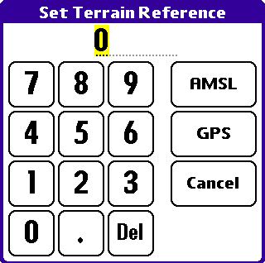
- Track Log. Draws the history of your actual flight path
The Terrain Altitude Reference setting allows you to see the terrain warning picture as though you were at a lower altitude. This can be useful when approaching an airfield with a known cloud-base. Set the reference altitude (remember – Above Mean Sea Level) to the cloud base, and then you can see exactly where the terrain will conflict with your aircraft as you approach under the cloud.
This feature also works when the GPS is off, and the map is in preview mode. It can be a great flight planning aid to help you see the effect of a low cloud base on your flight.
Tap on the terrain reference value and select GPS to reset your terrain references to GPS altitude.

PLAN rEVIEW mode
If the GPS is off (see the GPS Page section) then the Map Page is in review mode and allows you to see your route. The map centres on the current waypoint, which can be changed by selecting the “<<” and “>>” buttons.

Selecting Items on the Map

Waypoints
Select an icon by tapping on it. FlightMaster displays the name, bearing, range and ETE to the selected icon. For airfields with runway information, FlightMaster will show an 8nm approach path into each of the runways. This helps you orient yourself to the airfield. Warning: this is rough guidance only: the actual approach path can be wrong by up to 5 degrees.

Finding Waypoints by Identifier
Enter up to 5 characters of the identifier (using either the keyboard or Graffiti feature of your PDA) then:
- SPACE – to select the waypoint or;
- ENTER – select the waypoint and scroll to it. Please see “Lesson 5 – Scrolling Around the Map” on page 28 for details on operating the map in Scroll mode.

Airspace
Select airspace or airways by tapping on a boundary. FlightMaster displays the name of the airspace, class (if available) and altitude limits. Altitude limits are shown in hundreds of feet (or metres), e.g. 10 = 1000 feet.

Cursor
If you tap on a position of the map to select airspace, or some location that is not near a waypoint, FlightMaster will display a cursor (see diagram). The cursor allows you to see distance and time to arbitrary points, and to program those points into your flight plan (using the F2 key).

Information
Press F1 + INFO to display information for the selected icon or airspace (see “Waypoint Information” on page 56).

Scrolling the Map
Scrolling allows you to view areas of the map away from your present GPS position. Activate Scroll mode by pressing Select.
Please see “Lesson 5 – Scrolling Around the Map” on page 28 for details on operating the map in Scroll mode.

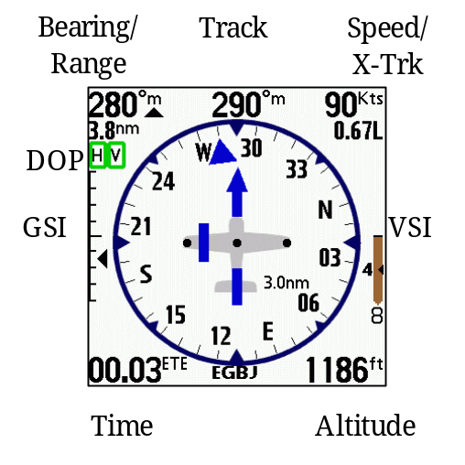HSI Page
This page shows either the Horizontal Situation Indicator (HSI) or the Attitude Approximator (AA). Tap once in the centre of the screen to toggle between the two.
If the GPS has a position fix, the screen will look similar to that shown in the diagram to the right.
The HSI and Flags are discussed in a later section.

Bearing To/From
Tap on the bearing to toggle between display of bearing-to and bearing-from.

Turn rate indicator
Arrows to the left or right of the track readout give a visual indication of bank angle:
- 1 green = 5-15 degrees
- 2 greens= 15-25 degrees
- 3 yellows=25-35 degrees
- 4 reds= > 35 degrees

VSI
The VSI shows rate of climb in altitude units per minute. The number on top or below the pointer is the rate of climb in hundreds of units, e.g. 3 = 300. During VNAV, the VSI shows a second, smaller digit to the left that indicates the target vertical speed required to reach the VNAV point.

GSI
The GSI shows any deviation from the VNAV profile. Each tick mark represents 100 feet or metres deviation from the VNAV profile. Unlike an ILS glideslope, the deviation does not get more sensitive as you near the end of the VNAV profile.

DOP
“H” represents horizontal dilution-of-precision accuracy, whereas “V” represents the vertical accuracy. Both relate to the estimated accuracy of the GPS fix – green is best, red is worst.

Time Display
All times are shown as “HH.MM” except for ETEs of less than 60 seconds which are shown as “-SS”. Tap on the time to change to the next display in sequence, which is one of:
- ETA is Estimated Time of Arrival at the waypoint (in local time)
- ETE is Estimated Time En-route to the waypoint
- LOC is the local time
- UTC is Zulu time (or Greenwich Mean Time)

Horizontal Situation Indicator (HSI)
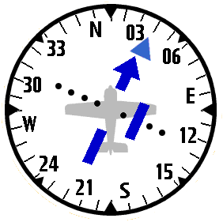
The HSI in the centre of the page shows heading, waypoint bearing, course direction and course deviation.
The heading display is similar to the heading/direction indicator found in most aircraft. It rotates so that the track of the aircraft is at the very top of the disc. The solid marker triangle points at the selected waypoint – if it is pointing straight up, then the aircraft is flying directly towards the waypoint. The Course Deviation Indicator drifts left or right of the centre to show your deviation from the planned course.
You may increase or decrease the sensitivity of the CDI by pressing Left or Right – the full-scale deflection is shown in the bottom right of the HSI.

Attitude approximator
WARNING
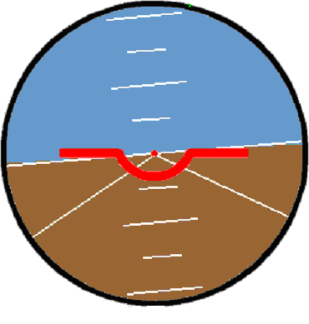
The AA is not intended for use as a primary attitude indicator. It is reliant upon GPS data signals, which cannot tell you which way up your aircraft is. It lags behind your aircraft’s movements by at least one second. If you misuse this device it could put your life and those of your passengers at serious risk. You must carefully read and understand the contents of this section so that you know the limitations of the device.
That having been said, if you are aware of the limits and have already tried the AA in a safe environment (see below), then there is a very good chance that the AA will help you keep your aircraft under control long enough to get to safety if you suffered sudden loss of your primary AI in IMC.
Tap once in the centre of the HSI page to display the AA.
The AA gives a graphical approximation of your aircraft’s attitude, within the limits of the signals supplied by the GPS. The GPS information that FlightMaster uses to drive this display is time, heading, speed, and altitude. This information imposes some critical limitations:
Limitation 1: GPS errors and accuracy
The AA may fluctuate as a result of sudden changes in GPS signal quality or accuracy; and you have no real way of discerning the difference between this and actual movement of your aircraft. GPS errors in the vertical plane are of particular concern, though augmentation systems such WAAS and EGNOS should help alleviate this.
Limitation 2: If you are upside down, the AA won’t show it
FlightMaster uses your GPS heading change over GPS time in conjunction with your GPS speed to approximate an angle of bank. For example, if you do a barrel roll to the left, your GPS heading change accelerates to the left then stops as you become inverted. Then it accelerates to the right and stops as you become upright. The AA would show this as a roll to the left, then wings level, then a roll to the right and then level again.
Similarly, the pitch angle as shown is driven by your GPS vertical speed (GPS altitude over GPS time). For example, if you do a loop your GPS vertical speed accelerates on the upward pull, then decelerates to zero when you are inverted at the top, and then accelerates (downwards) towards the bottom and finally reaches zero again. The AA would show this as a steep climb, then level flight, then a steep dive, and finally level flight again.
Limitation 3: The AA lags behind what’s actually happening
GPS receivers output data at the rate of 1Hz. In other words, FlightMaster must wait at least one second in order to determine what has changed between the two readings. This means that the display is always 1 second behind, and you need to anticipate this lag - otherwise you may end up with pilot-induced oscillation leading to a loss of control.
Limitation 4: Pitch is actually flight-path
FlightMaster uses GPS vertical speed to approximate your pitch – if vertical speed is zero, that’s what the AA shows. If you are in slow flight, you could be pitching up by 10 degrees or more in level flight, but the AA still shows 0 degrees. Keep a good watch on your airspeed indicator!
A side effect of this limitation is that the AA gives a fairly accurate indication of glide-path, GPS signal quality permitting.

Safe Practice with the AA
If you have a Flight Simulator capable of outputting NMEA messages, and a serial connection to your PDA, then you can use this method to practice with. Flight Simulator 2002 requires extra software (FSUIPC and GPSout) to output NMEA messages; there is plenty of help on the web for this - Google is your friend here.
Another way to practice is to fly with a safety pilot, so you have someone who can watch out while you study the behaviour of the AA. Or, you can simply mount your PDA in your car and observe it that way.

FLAGS & Warning Messages
FlightMaster displays small, bounded text boxes (flags) to alert you to certain conditions. The flags are:
- BC – Back Course; you have flown past the end of your leg. It may take a few moments for FlightMaster to notice that you are on the back-course.
- VP – Vertical Precision. This appears on the AA, to indicate that GPS vertical accuracy is below that required by the AA.
- Hz – Hertz (update frequency). This appears on the AA, to indicate that the GPS data is not arriving frequently enough to drive the AA.
FlightMaster displays “No Position Fix” while the GPS is not providing a position fix, but is providing other valid GPS data.
FlightMaster displays “GPS Not Detected” when it stops receiving any input from the GPS. This is a serious condition, possibly indicating that the GPS battery has failed, or a cable has come loose (if you’re using one), or a hardware failure of the PDA or the GPS unit.

Flight Plan Page
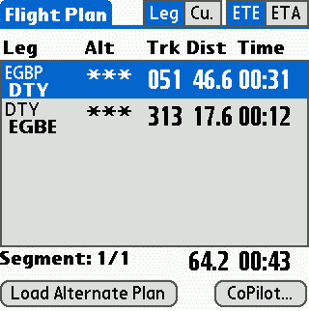
The Flight Plan Page shows the flight plan and some dynamic data which is updated every 8 seconds. The page is designed to give you time and distance data about your flight, and to remind you of altitudes and planned tracks.
Each leg is shown in a separate line comprising start & end waypoint Ids, altitude, track, distance and time. The total plan distance and time is shown underneath the leg list.
Select A<->B to switch plans.
The Leg / Tot (total) and ETE / ETA toggles at the top right control the data in the distance and time columns. When Tot is selected the distance and time fields are totalled at each leg. The time column is valid when GPS position and speed are available.
Use Up and Down or tap on a leg in the list to change the active leg.
The distance and time columns for the current leg in an active plan are determined using your present GPS position and speed. However the track (Trk) field is always what was planned originally i.e it is not the current bearing to the waypoint.

Search Page
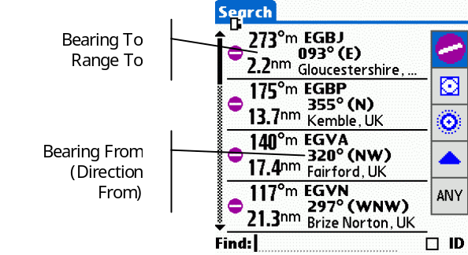This page shows a list of the nearest waypoints.
FlightMaster looks within 2000nm of your position for the waypoints and shows the nearest four waypoints of the selected type. The list can contain up to 16 waypoints, scroll the list using Up and Down.
Select a waypoint from the list by tapping on it; this opens the Waypoint Information dialog.
The search page works using your present GPS position, or the last viewed map position if the GPS is OFF. FlightMaster displays a clock icon in the top right of the screen while it is busy searching and the list will fluctuate while the search is underway.
The buttons on the right of the display control what type of waypoints to show.
Note that for airfields FlightMaster only shows airfields that satisfy the landing minimums entered into the “More Preferences” dialog. The icons show the longest runway that is usable by your aircraft as determined from the Landing Minimums.

Searching for a waypoint
FlightMaster can search for a waypoint with specific text in the waypoint identifer or name fields. For instance, you can search for Kemble by its identifier (EGBP) or name (Kemble).
To perform a search, tap on the “Find:” field at the bottom of the page, enter your text into the keypad dialog that appears and press OK.
If the “ID” checkbox is selected, FlightMaster performs an identifier search – this is very quick.
Deselect the “ID” checkbox if you want FlightMaster to search both the ident and the name fields of the waypoint – for instance, you might use this if you know the name of the airport but not its identifier. This search will always take much longer than a search on the identifier.
Note that when searching for text, FlightMaster will include all airfields regardless of runway dimension or surfaces.

Timers Page

Overview
FlightMaster supports four independent timers. Each timer can be given a 6-character identifier and set to count up, count down, and to recycle or stop when it hits zero.
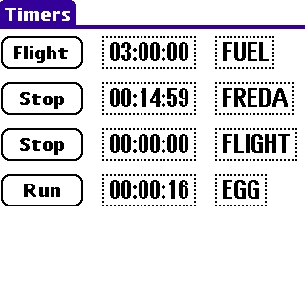
Timers can be set to run permanently, or to run only when your aircraft is moving >35kts:
Run Timer is running
Stop Timer is stopped
Flight Timer runs only when the GPS speed is >35kts
FlightMaster sends you a message when a count down timer expires. If audio is enabled, you will also hear a voice alert.

Naming the timers
Tap on the name of the timer to open the alpha-pad dialog and enter a name for the timer.

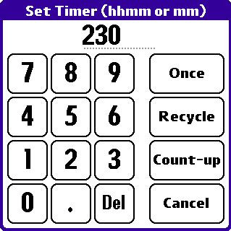
Setting the timer
Tap on the current timer value to open the Set Timer dialog.
To set a count-down timer, enter an initial timer value then select Recycle to setup a timer that recycles when it hits zero, or Once to have the timer stop.
Select Count-up to have the timer count upwards from zero.
Timer input values are either M, MM, HMM, or HHMM where M = minutes, and H=hours:
e.g. 5 = 5 mins 55 = 55 mins 230 = 2 hours 30 mins 1022=10 hours 22 minutes

Waypoint Information
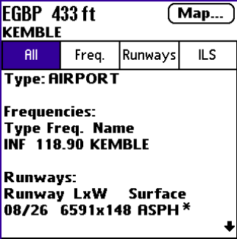The waypoint information dialog presents information about a selected waypoint.
Press F1 + Info to open the waypoint information dialog. You can then use the buttons to control what sort of information to display about the waypoint. Scroll the information list by using Up and Down.
Press F2 to reroute from your present position to the waypoint.
Press Map to show the waypoint on the moving map page.

Omni Bearing Selector
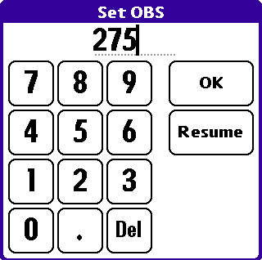
The OBS functions like the OBS knob on a standard VOR. It allows you to select a radial from the current waypoint, rather than the course that you have set in your flight plan. After you have set a bearing using the OBS dialog, you can see this new radial reflected on the map and on the HSI – it becomes your new course to the waypoint.
Press F1 + OBS to set up the Omni-bearing function.
Press F1 + OBS + Resume to clear the OBS and resume your original plan.

Flight Monitoring

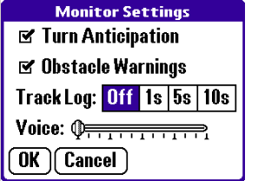Introduction
FlightMaster is able to monitor several aspects of your flight, providing guidance and alerts as required. The monitoring functions are accessible by selecting F1 + Monitor .

Turn Anticipation
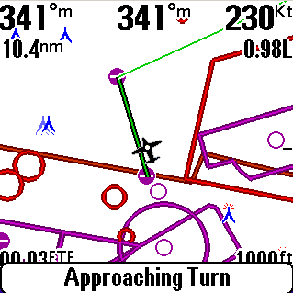
Turn Anticipation is an aid designed to let you make a smooth transition from one leg to the next in your flight plan. FlightMaster will monitor your progress as you approach the turning point. You will receive a system message when you are within 2 minutes of the turning point.
At 60 seconds or less to the turn point, FlightMaster displays a countdown timer on the bottom-left of the Map and HSI pages – ETT = “Estimated Time to Turn”. When the timer hits zero, the leg will automatically advance to the next leg and you should commence a 20° bank onto the new heading.
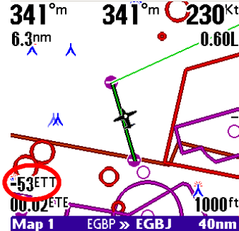FlightMaster will not advance to the next leg if you are presently flying a VNAV profile – the leg will hold until the VNAV is completed, but the countdown timer will still indicate when you should start your turn.
Turn anticipation does not work if the angle of turn required is more than 90°. The countdown timer is based upon the assumption that you are flying towards the waypoint – if you are pointing away from the waypoint then the timer will appear to slow down, or even go backwards. In any event, the leg will auto-advance when you fly past the end of the current leg.

Roll Rate Indicator
FlightMaster displays a guidance indicator, to the left or right of the track value on the Map and HSI pages, which assists a smooth turn onto the active leg of your flight plan. Each full bar represents 10 degrees of bank required in order to intercept the leg.

Obstacle Warnings
FlightMaster will alert you to obstacles that are within 5nm and 1000 feet of your present position. FlightMaster will only warn you about the first obstacle in an area – you need to clear the obstacle alert by leaving the area or climbing, before FlightMaster will warn you again.

Track log
FlightMaster can maintain two track logs that log the history of your flight(s); one is held in the internal memory of the PDA and can be displayed on any of the map pages. It is about 8000 points long, does not store altitude information, and when it is full the oldest data is removed first. The second log is stored on the external card in the file ‘FM-Track.txt’. This file is in tab-separated ASCII format, and stores time, position, altitude, course and speed.
The track log interval setting on the Monitor Dialog affects the internal and external log intervals. At the maximum interval of 10 seconds the internal log is capable of storing over 22 hours of flight information.
Selecting ‘Clear Track’ from the main menu clears both track logs.

Voice Alerts
Turn on voice alerts using the slider to adjust the volume control. The following audio alerts are given:
- Approaching Turn
- Approaching VNAV
- Turn Left/Right onto [000-359] degrees
- Warning: Obstacles
- Climb/Descend altitude [0-xxxxx]
- Timer [1-4] has expired

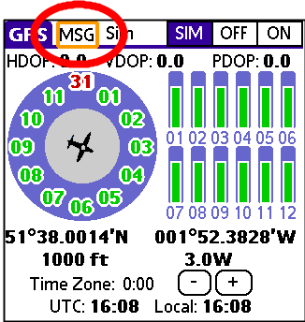System Messages
FlightMaster alerts you to events by use of a Message Indicator that appears at the top of the GPS, Flight Plan, Search and Timer pages.
The indicator may flash green or amber depending on the urgency of the message, and there may be more than one message to read – in this case the indicator flashes the colour of the most urgent one.
The diagram to the right illustrates the MSG flag in amber state.
On the HSI and MAP pages, the entire message is presented on a banner at the bottom of the page for 8 seconds, and then automatically disappears and becomes the MSG flag afterwards.
When a message is displayed on any screen press F1 to read the message, and press it again (or tap OK) while the message dialog is displayed to read the next message if one is available.
Each message has actions associated with it, for example the Obstacle Warning allows you to go directly to a map view.
The messages you may see are:
- Obstacle Warning (Amber). FlightMaster has detected an obstacle within 5nm and 1000ft of your position. Select Off to turn off obstacle warnings, or Map to see the obstacles on Map 4. FlightMaster will only warn you about the first obstacle – you need to clear the obstacle alert by leaving the area or climbing clear before FlightMaster will warn you about subsequent obstacles.
- Turn < 2 Minutes (Green). You are within 2 minutes of making a turn on to your next leg. Select Off to turn off Turn Anticipation.
Kev says:
“If you don’t acknowledge a message in 60 seconds it will automatically expire.”
- VNAV < 2 Minutes (Green). You are within 2 minutes of the start of a VNAV event. Select VNAV to review VNAV settings.

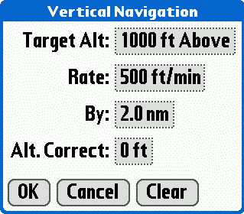
Vertical Navigation

Introduction
Vertical Navigation – VNAV – is the term given to navigating an aircraft in the vertical plane, i.e. changing altitude. FlightMaster has three modes of VNAV available to the pilot to assist in getting the aircraft from one altitude to another on a certain profile and by a certain point in the flight plan.
Press F1 + VNAV to open the VNAV dialog settings for the current leg.
WARNING: It is possible to use the VNAV feature to fly final approaches, however FlightMaster is not to be used as primary approach guidance.

Setting up a VNAV profile
You may set a VNAV profile at any time along the current leg. FlightMaster will pre-select some sensible target-altitude values for the current leg of your plan, so in many cases a VNAV can be quickly set up.
If you have the time (perhaps before start-up), it is possible to preset VNAV profiles on the next few legs, and FlightMaster will activate them in turn. This is easily done from the Flight Plan page. Manually select the leg you want to pre-program and set up the VNAV profile – do this for each leg you want a VNAV profile for. Then manually reselect your present leg.
VNAV profile information is lost when you load a new flight plan.
There are three settings controlling the VNAV profile.

Target Altitude
Tap on the Target Altitude control to change the target altitude. You may specify a target altitude in terms of Above Mean Sea Level (AMSL) or above the waypoint (Above).

Rate
FlightMaster supports three rate settings for a VNAV profile: feet per minute, feet per mile or degrees.
For feet per minute rate note that the actual slope of the VNAV is determined by your groundspeed at the point at which the VNAV begins. Therefore it is important to make sure that your aircraft is travelling at descent or climb speed before the VNAV event starts, and if your ground speed changes during the VNAV event then you may need to adjust your rate of descent or climb.

by
FlightMaster allows you to specify a distance before the waypoint by which you want to achieve the target altitude.

Approaching VNAV profile
FlightMaster will warn you with a system message when you are within 2 minutes of the start of a VNAV event, and display a countdown timer on the Map and HSI pages when you are within 60 seconds of the event – ETV = Estimated Time to VNAV. The timer assumes you are flying directly towards the waypoint; if you are not then the timer will appear to count more slowly.
FlightMaster displays the GSI and Required Rate Indication when you are within 2 minutes of the start of the VNAV event.

Flying the VNAV profile
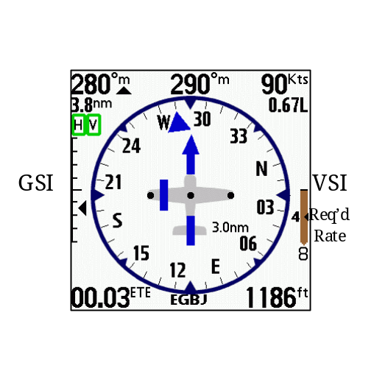The VNAV event begins once the VNAV timer hits 0. For a profile requiring a feet per minute rate of descent, FlightMaster will calculate a fixed profile based on your present groundspeed – in this mode it is important to have set the aircraft’s speed in advance of the event.
FlightMaster displays two instruments that help you fly the VNAV profile.

GSI
The Glide Slope Indicator (GSI) is on the left of the Map and HSI pages. The GSI is calibrated with lines every 100 feet (or metres). The GSI pointer is above the centre if you are below the profile – one tick above centre means you are 100 feet below profile.
In the diagram, the aircraft is 150 feet above the profile.

Required Rate indicator
FlightMaster displays a very helpful indicator in the form of the required rate of descent/climb, overlaid on the vertical speed indicator. The units are in hundreds of feet (metres) per minute. If you set your rate of climb/descent to the value indicated then you would hit the target altitude at the point you originally planned.
In the diagram, a rate of 400 feet per minute is required to hit the target.

Ending the VNAV event
FlightMaster displays the ETV countdown timer when within 60 seconds of the end of the VNAV event. The VNAV event ends when one of the following conditions occurs:
- Your altitude is +/- 100 feet of the target altitude
- You fly over the waypoint, or within the ‘By’ distance specified of the waypoint

Database Management

Updating The System Waypoint Database
FlightMaster must analyse the waypoint databases after they are updated. If the database is large then this task will take minutes to complete.
Note the maximum of 32767 waypoints in each database in both CoPilot and FlightMaster.

external databases
FlightMaster supports the use of a CoPilot database that is loaded onto an external card, such as an SD card. FlightMaster looks on the external card first, then in main memory (as does CoPilot).
Note that external card access is slower than internal memory – this has an affect on search performance on the Search Page, when searching for text strings in waypoints.
Editing Flight Plans
You can edit your flight plan using the TapPlan feature of the Map page. The changes are not saved back into the CoPilot flight plan, but your current flight plan state is saved when you exit FlightMaster and restored when you run it again.
The state is not restored if the waypoint databases change, or you launch FlightMaster from within CoPilot.

Part III Appendices

Appendix A – databases

General
The following databases are supported:
Type | PDA | SD Card
Waypoint | CoPilot_Waypoint.pdb | /PALM/Programs/CoPilot/CoPilot_Waypoint.pdb
Waypoint | CoPilot_User.pdb | Not supported
Airspace | FlightMaster7-Airspace.pdb | /PALM/Launcher/FlightMaster7-Airspace.pdb
TFR | FlightMaster7-TFRS.pdb | Not supported
Obstacle | Not Supported | /PALM/FM/FlightMaster7-Obstacle0.fma
Terrain | Not supported | /PALM/FM/FlightMaster7-Terrain.fma
Terrain Palette | Not supported | /PALM/FM/FlightMaster7-Palette.fma

Airspace
Airspace data is not integral to FlightMaster and is read from a database that must be loaded onto your PDA. FlightMaster supports two airspace databases, one is a base map of fixed airspace and the other is intended for Temporary Flight Restrictions & NOTAMS. See the website for further information on obtaining databases.

FMA File
FMA airspace files are plain-text based files that FlightMaster can read from an external storage card, and build the airspace database from them. The text files are human-readable but are best produced by software processing. See the website for the FMA format specification for airspace databases.
FlightMaster associates itself with the .fma format, so that you can use the HotSync tool to copy an FMA file to your external storage card (the files are stored in /PALM/FM on the card). The files must be called “airspace.fma” for the base airspace model, or “tfrs.fma” for the TFRs/NOTAMS.
Once an FMA file is on the card, use the “Import base” or “Import TFRs” menu option from the Map menu to install the database. Note that FlightMaster will remove your old database first, so that if this import process fails because of an error in the FMA file then you will be left without an airspace database.
After the successful import of an FMA file, you may HotSync your PDA and then locate the resulting .PDB file on your desktop computer: FlightMaster7-Airspace.pdb or FlightMaster7-TFRS.pdb. The PDB file may be taken and directly installed on any other PDA, or perhaps distributed from your own website.

Appendix B –
CoPilot Waypoint Notes
This appendix examines the contents of the Waypoint Notes field generated by the waypoint generator at http://navaid.com. FlightMaster interprets the notes in order to determine the waypoint types, frequencies and the runway dimensions & surface information.
If you’ve added airports or navigation aids to your CoPilot User Database and want FlightMaster to classify them correctly then you need to format the Notes field of the waypoint according to the guidance in this appendix.

Type field
The basic classification of a waypoint is determined from the type field:
Type: <WS> <Type>\n

Key: “\n” represents a new line, i.e. a return
<WS> is a white-space character, such as a tab or space
FlightMaster understands the following types:
<Type> | Icon
AIRPORT | Airfield
VOR | VOR
VOR/DME | VOR/DME
VORTAC | VORTAC
DME | DME
TACAN | TACAN
NDB | NDB
NDB/DME | NDB
OBSTACLE  OBSTACLES  OBSTACLE-L  OBSTCALES-L | Obstacle/Obtacles  -L=Lighted
REP-PT  WAYPOINT | Intersection
TOWN | Town/City
VRP | Visual Reference Point
<None of the above> | +

Runway Information
The additional text for an airfield record looks like this:
Runways:\n
Runway LxW Surface\n
03/21 1148x66 GRS\n
08/26 6591x148 ASP\n
09L/27R 1476x66 GRS\n
13/31 3087x150 ASP\n

See appendix C for the list of runway surfaces that are considered ‘hard’.

Airfield Frequencies
Airfield frequencies are described in a similar format to the airfield runways (above). For example
Frequencies:\n
Type Freq. Name\n
AFIS 118.9 INFO\n

Navigation Aid Frequencies
Navigation aids can have frequencies associated with them.
Frequency: <TAB> 116.40\n

ILS Information
ILS:\n
Rwy Hdg Freq.\n
26L 263 110.10 / IAA\n
26R 263 110.20 / IAB\n

Hard Surfaces
This is a list of the runway surfaces that FlightMaster categorises as ‘hard’ for the purposes of Landing Minimums (see More Preferences). All other surface descriptions are ‘soft’ by default.

ALPHALT
ALUM
ALUM-DECK
ALUMINUM
ASHP-G
ASP
ASP/TURF
ASPH
ASPH-CONC
ASPH-CONC-F
ASPH-CONC-G
ASPH-CONC-P
ASPH-DIRT
ASPH-DIRT-F
ASPH-DIRT-G
ASPH-DIRT-P
ASPH-F
ASPH-G
ASPH-GRVD
ASPH-GRVD-F
ASPH-GRVD-G
ASPH-GRVL
ASPH-GRVL-F
ASPH-GRVL-G
ASPH-GRVL-P
ASPH-P
ASPH-TRTD
ASPH-TRTD-F
ASPH-TRTD-G
ASPH-TRTD-P
ASPH-TURF
ASPH-TURF-F
ASPH-TURF-G
ASPH-TURF-P
ASPHALT
ASPHALT/GRAVEL
ASPHALT/TURF
BIT
BRI
BRICK
BRICK-F
CON
CONC
CONC-ASPH
CONC-ASPH-F
CONC-ASPH-G
CONC-DIRT
CONC-F
CONC-G
CONC-GRVD
CONC-GRVL
CONC-GRVL-F
CONC-P
CONC-TRTD-G
CONC-TURF
CONC-TURF-F
CONC-TURF-G
CONCRETE
CORAL
CORAL-F
DECK
LAT
MAC
METAL
OLD
PACKED
PEM
ROOF-TOP
ROOFTOP
STEEL
STEEL-CONC
WOOD

Appendix C - Checklist
Please feel free to adapt this list to your own needs as necessary.

Cockpit
SD Card Inserted
PDA Software Loaded
PDA mount Secure
GPS mount Secure
Cables Attached
GPS/Power Cables Clear of controls

After Engine Startup
GPS/PDA On
Power Check battery/charging cables
FlightMaster Load
Day/Night Toggle As required
GPS Page GPS connection ON
GPS Acquiring Satellites Check

Flight Plan Page Load flight plan
VNAV Legs As required
First leg Selected

Timers Initialise as required
Map pages 1-4 Settings as required
Map page Select map for takeoff

Monitor Settings
Turn Anticipation As required
Obstacle Warnings As required
Track Log As required

Map/HSI Select as required

Aircraft Installation
It is important to consider where you will mount your PDA & GPS receiver. Here are some useful tips:
- Install it where satellite reception is possible (don't wait until you're airborne to find out it won't receive!)
- Ensure that it will not interfere with the aircraft controls
- Ensure that you can easily reach the screen and buttons
- Ensure that you can see it! Try to account for potential lighting problems (e.g. sun position, night lighting) and screen size limitations.
- If possible, make sure it can be included in an instrument scan. If you’re using FlightMaster in IMC (as a backup) then it is especially important to place it where you don’t have to make excessive head movements that may induce false sensations of turning or climbing.
- Ensure that it is secure - so it won't drop onto the floor in turbulence

Appendix D – Device-Specific Information

Garmin iQue
The Garmin iQue does not feature a 5-way navigator, however the thumbwheel on the left hand side acts as the Left, Right and Select (push-in) buttons.
The Garmin has a power saving feature that can be taken advantage of in FlightMaster. When activated, the screen will switch off after a period of inactivity to save power. To turn the screen back on press the power button at the top of the unit.
Press and hold the ESC button on the left-hand side to activate or de-activate the power saving feature.

Palm Treo
The Palm Treo has a keyboard that can be used to enter waypoint identifiers on the map page. The Alt button can be used to toggle between your active and standby plans i.e. it functions as the A<->B button does.

Palm T3
The Palm T3 has a non-standard button layout, as shown below:
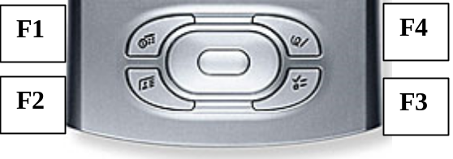
The Palm T3 is capable of 320x480 resolution in FlightMaster only if the T3 DIA (Dynamic Input Area) patches have been installed. These are not included in FlightMaster for licensing reasons, however they are easy to find via Google or the forums at the FlightMaster website.

